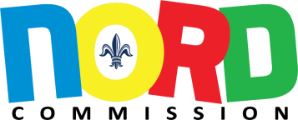

NORD Commission Meeting Agenda
Tuesday April 2, 2024 @ 5pm
City Council Chambers
1300 Perdido St. Room 1E07
New Orleans, LA 70112

To send in public comments prior to the meeting email
gogatewood-lucas@nola.gov (504) 658-3043

- CALL TO ORDER

- ROLL CALL

- GREETINGS FROM THE CHAIR

- ADOPTION OF AGENDA (*Action Item)

- ADOPTION OF MINUTES (*Action Item)

January 10, 2024

February 6, 2024

COMMITTEE REPORTS

- OLD BUSINESS

- NEW BUSINESS

- CHIEF EXECUTIVE OFFICER’S REPORT

Report from the Chief Executive Officer, Larry Barabino, Jr.

- CAPITAL PROJECTS REPORT

Report from the Director of Capital Projects, Vincent Smith

- CONSIDERATION OF ANY OTHER MATTERS

- PUBLIC COMMENT

- ADJOURNMENT

